BALLYMORRIS: CHILDREN’S BURIAL GROUND
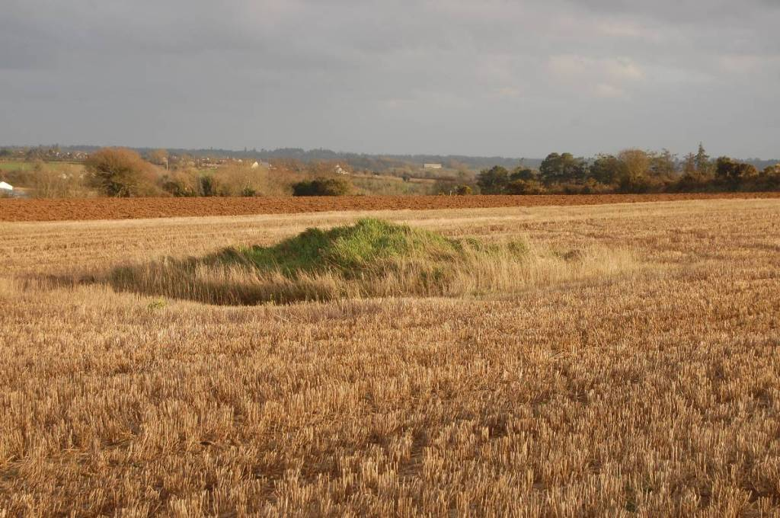
The children’s burial ground (cillín) at Ballymorris (WX031-057), Co. Wexford is located in a very large arable field near the summit of a low hill. It survives as a small mound of overgrown stones and earth, which measures c. 4 wide by 6m long by 1m high. Children’s burial grounds are known by various names such as, cillín/killeen, calluragh/ceallunach and lisín, and they reflect a sadder part of our more recent past. They were the designated resting place for still-born and unbaptised children as well as other members of society who were deemed unsuitable for burial within consecrated ground. The latter grouping included, amongst others, suicides, unrepentant murderers, the mentally disabled and those of different religious beliefs. The mound at Ballymorris is known locally as ‘Crishavale’ (pers. comm Nick Dempsey junior, told to him by his father Nick senior). The first part of this name, Crisha is probably a corruption of the Irish for cross, while the meaning of the second part, vale, is uncertain (see Note 1 at the bottom). The local landowner (Paddy Breen) also referred to the site as a ‘fairy’s graveyard’.
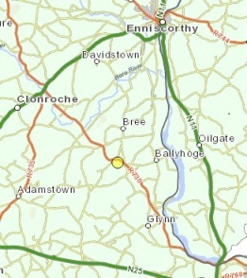Ballymorris cillín location (© National Monuments Viewer)
The dating of children’s burial grounds/cilliní has been problematic with some earlier commentators, such as O’Suilleabheán, suggesting that they may have had their origins in pre-Christian pagan practices (O’Suilleabheán 1939, cited in Finlay 2000). However, recent research and the results of a number of archaeological excavations indicate that the majority date from the 16th century AD onwards (see Donnelly & Murphy 2008). This may have been the result of the Counter Reformation, which was initiated by the Council of Trent (1545-1563). This movement sought to re-establish the primacy of the Catholic Church in the face of an expanding Protestant faith. Among its many proclamations the Council of Trent issued edicts on the importance of baptism and the concept of Limbo as well as reaffirming canon law, with its measures on who could and could not be buried in consecrated ground. In Ireland it appears that these measures led to a significant growth in the use of cilliní sites, such as Ballymorris.
Quite simply, if an infant remained unbaptised at the time of its death, its soul was bound for Limbo; its body, for the cillín (after Donnelly & Murphy 2008) . It is hard not to feel deep sympathy for the parents of such children. The grief they undoubtedly felt at the death of their child was now compounded by a church doctrine which deemed their offspring unworthy of burial in consecrated ground and access to heaven. Folklore evidence suggests that even the act of burial was now something to be ashamed of. It was typically carried by male members of the family, usually the father, at night with little or no ceremony (Sugrue 1993, cited in Finlay 2000).
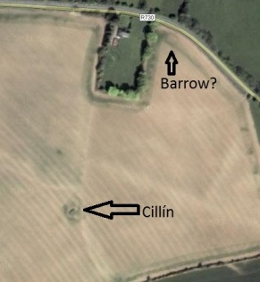Cillín location in relation to possible barrow
At Ballymorrris it is possible that the mound of stone and earth which marks the cillín may also represent a much earlier phase of burial activity, possibly a barrow. This reuse of earlier monuments is often seen as cilliní sites, with locations such as deserted churches and graveyards, ancient megalithic tombs/mounds, and secular earthworks such as ringforts often chosen. Barrows are small burial mounds that typically date to the Bronze (2,500-700 BC) or Iron Age (700BC-400AD) and which present as small mounds of earth and stone surrounded by a circular ditch (although the mound rarely survives and ditch is often filled in with silt and soil). They often occur in clusters and at Ballymorris a second possible barrow is located roughly 100m to the northeast of the cillín (see image above). No mound survives at this previously unrecorded site, but the presence of an enclosing ditch c. 15m in diameter is suggested on aerial photos (Google Maps satellite image, accessed 14th of Jan 2012). In the image below the barrow ditch is represented by a dark circular cropmark.
Whatever the antiquity of the children’s burial ground at Ballymorris, there is no denying that it represents one of the sadder parts of our parish’s heritage.
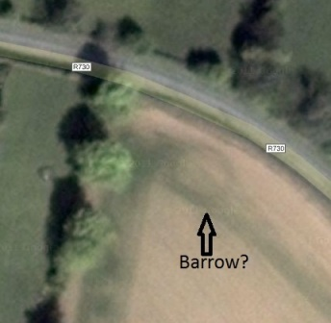Close up of possible barrow/ring-ditch located to the northeast of cillin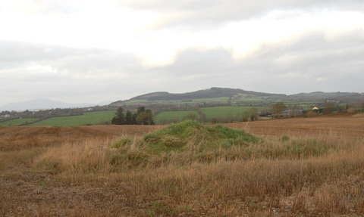Cillín mound looking northwest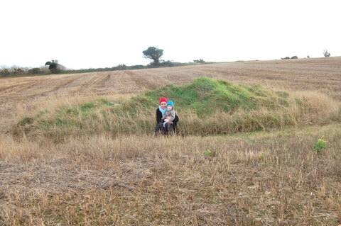Cillín mound looking southeast
Note 1
Crisha probably represents the tuiseal ginealdach verion of the Irish word for a cross (croise), which suggests that Crisha was orginally preceded by a noun, which has since been forgotten. It’s posssible that the orginal name of the graveyard was ‘cillin croise vale’, with the meaning of vale still uncertain.
References
Donnelly, C. & Murphy E. 2008. The Origins of Cilliní. Archaeology Ireland, Vol. 22, No. 3, pp. 26-29
Donnelly, S. et al. 1999. The Forgotten Dead: The cilliní and Disused Burial Grounds of Ballintoy, County Antrim, Ulster Journal of Archaeology, Third Series, Vol. 58, pp. 109-113
Finlay, N. 2000. Outside of Life: Traditions of Infant Burial in Ireland from Cillin to Cist.World Archaeology, Vol. 31, No. 3, Human Lifecycle, pp. 407-422

